Business Report

IS Coded Project
By
Rajesh Mambulli

Table of Contents
IS Coded Project 1
Table of Figures 3
Problem 1: 4
1.1 What is the probability that a randomly chosen player would suffer an injury? 4
1.2 What is the probability that a player is a forward or a winger? 4
1.3 What is the probability that a randomly chosen player plays in a striker position and has a foot injury? 4
1.4 What is the probability that a randomly chosen injured player is a striker? 5
Problem 2 6
2.1 What proportion of the gunny bags have a breaking strength of less than 3.17 kg per sq cm? 6
2.2 What proportion of the gunny bags have a breaking strength of at least 3.6 kg per sq cm.? 6
2.3 What proportion of the gunny bags have a breaking strength between 5 and 5.5 kg per sq cm.? 7
2.4 What proportion of the gunny bags have a breaking strength NOT between 3 and 7.5 kg per sq cm.? 8
Problem 3 9
3.1 Zingaro has reason to believe that the unpolished stones may not be suitable for printing. Do you think Zingaro is justified in thinking so? 9
3.2 Is the mean hardness of the polished and unpolished stones the same? 10
Problem 4 11
4.1 How does the hardness of implants vary depending on dentists? 12
4.2 How does the hardness of implants vary depending on methods? 12
4.3 What is the interaction effect between the dentist and method on the hardness of dental implants for each type of alloy? 13
4.4 How does the hardness of implants vary depending on dentists and methods together? 14

Table of Figures
Figure 1: Norm. distribution of gunny bags 6
Figure 2: Norm. distribution of gunny bags 7
Figure 3: Norm. distribution of gunny bags 7
Figure 4: Norm. distribution of gunny bags 8
Figure 5: Top 5 Rows of Zingaro Stone printing dataset 9
Figure 6: Last 5 Rows of Zingaro Stone printing dataset 9
Figure 7: Dental implant data 11
Figure 8: Data Description of Dental Implant data 11
Figure 9: Alloy Types in Dental implant data 11
Figure 10: Evidence of p-value 12
Figure 11: Evidence of p-value 12
Figure 12: Evidence of p-value 12
Figure 13: Evidence of p-value 13
Figure 14: Evidence of p-value 13
Figure 15: Evidence of p-value 13
Figure 16: Evidence of p-value 14
Figure 17: Evidence of p-value 14

Problem 1:
A physiotherapist with a male football team is interested in studying the relationship between foot injuries and the positions at which the players play from the data collected.
 | Striker | Forward | Attacking Midfielder | Winger | Total
Players Injured | 45 | 56 | 24 | 20 | 145
Players Not Injured | 32 | 38 | 11 | 9 | 90
Total | 77 | 94 | 35 | 29 | 235

What is the probability that a randomly chosen player would suffer an injury?

Total number of players = 235
Number of players injured = 145

Probability (Injury) = Number of players injured / Total number of players
Probability (Injury) = 145/235 = 0.617

What is the probability that a player is a forward or a winger?

Total number of players = 235
Number of forwards = 94
Number of wingers = 29

Probability (Forward or Winger) = (Number of forwards + Number of wingers) / Total number of players

Probability (Forward or Winger) = (94+29) / 235 = 0.523

What is the probability that a randomly chosen player plays in a striker position and has a foot injury?

Total number of players = 235
Number of injured strikers = 45

Probability (Striker and Injury) = Number of injured strikers / Total number of players
Probability (Striker and Injury) = 45/235 = 0.1915

What is the probability that a randomly chosen injured player is a striker?

Total number of injured players = 145
Number of injured strikers = 45

Probability (Injured and Striker) = Number of injured strikers / Total number of injured players

Probability (Injured and Striker) = 45 / 145 = 0.310

Problem 2
The breaking strength of gunny bags used for packaging cement is normally distributed with a mean of 5 kg per sq. centimetre and a standard deviation of 1.5 kg per sq. centimetre. The quality team of the cement company wants to know the following about the packaging material to better understand wastage or pilferage within the supply chain; Answer the questions below based on the given information; (Provide an appropriate visual representation of your answers, without which marks will be deducted)

2.1 What proportion of the gunny bags have a breaking strength of less than 3.17 kg per sq cm?
The proportion of gunny bugs having breaking strength less than 3.17 kg per sq cm is 0.1112
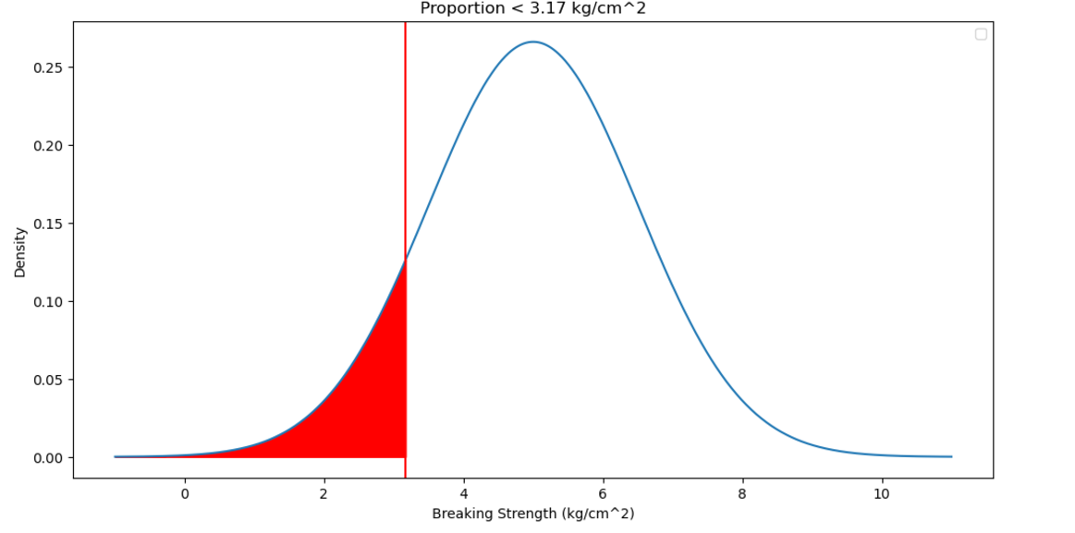
Figure 1: Norm. distribution of gunny bags

2.2 What proportion of the gunny bags have a breaking strength of at least 3.6 kg per sq cm.?

The proportion of gunny bugs having breaking strength of at least 3.6 kg per sq cm is 0.8247
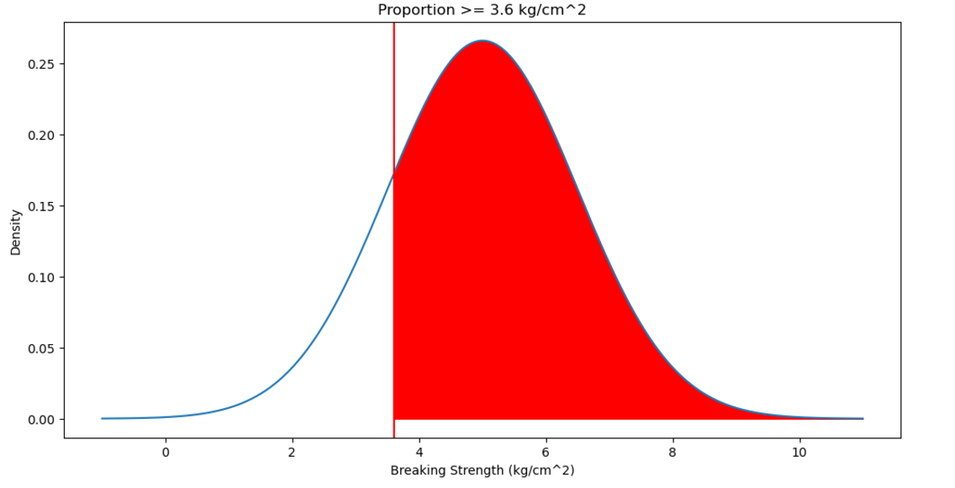
Figure 2: Norm. distribution of gunny bags

2.3 What proportion of the gunny bags have a breaking strength between 5 and 5.5 kg per sq cm.?
The proportion of gunny bugs having breaking strength between 5 and 5.5 kg per sq cm is 0.1306
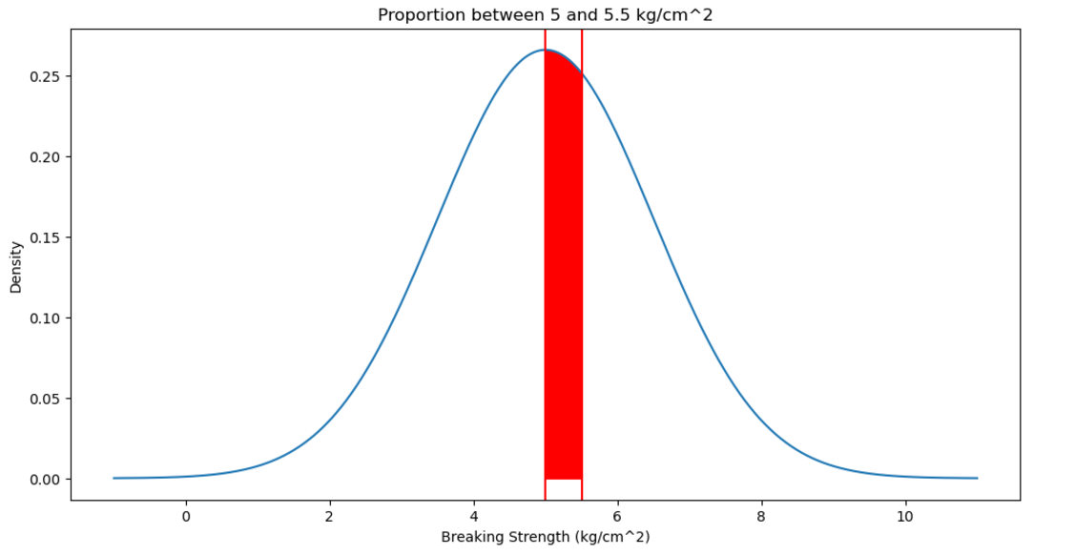
Figure 3: Norm. distribution of gunny bags

2.4 What proportion of the gunny bags have a breaking strength NOT between 3 and 7.5 kg per sq cm.?
The proportion of gunny bugs having breaking strength NOT between 3 and 7.5 kg per sq cm is 0.1390
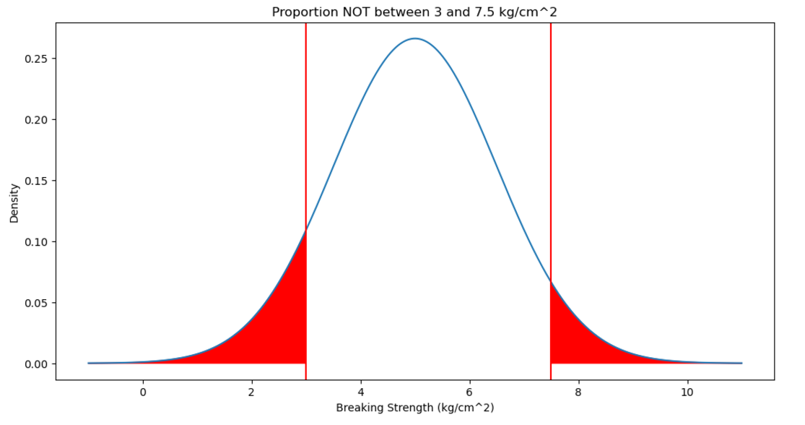
Figure 4: Norm. distribution of gunny bags

Problem 3

Zingaro stone printing is a company that specializes in printing images or patterns on polished or unpolished stones. However, for the optimum level of printing of the image, the stone surface has to have a Brinell's hardness index of at least 150. Recently, Zingaro has received a batch of polished and unpolished stones from its clients. Use the data provided to answer the following (assuming a 5% significance level);
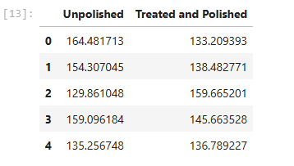
Figure 5: Top 5 Rows of Zingaro Stone printing dataset
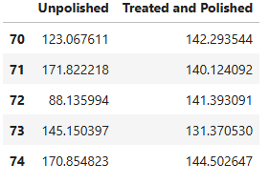
Figure 6: Last 5 Rows of Zingaro Stone printing dataset

3.1 Zingaro has reason to believe that the unpolished stones may not be suitable for printing. Do you think Zingaro is justified in thinking so?

One-sample t-test for unpolished stones
Let us write the null and alternative hypothesis
Let μ be the mean delivery time of the Zingaro data.
Test of null hypothesis:
Null Hypothesis (H₀): μ ≥ 150 (The mean hardness is at least 150)
Test of alternate hypothesis:
Alternative Hypothesis (Hₐ): μ < 150 (The mean hardness is less than 150)

Decision rule at 5% significance level alpha = 0.05
As per the T test, it is evident that P value is 4.171286997419652e-05 and is less than 5% level of significance.
From above insight, Null Hypothesis should be Rejected, and Alternate Hypothesis should be accepted.
Hence, Zingaro is justified in thinking that the unpolished stones may not be suitable for printing.

3.2 Is the mean hardness of the polished and unpolished stones the same?

To compare the mean hardness between Treated and Polished and unpolished stones,
Conducting a two-sample t-test.
Hypothesis:
Null Hypothesis (H₀): μ₁ = μ₂ (The mean hardness of polished and unpolished stones is the same)
Alternative Hypothesis (Hₐ): μ₁ ≠ μ₂ (The mean hardness of Treated and Polished and unpolished stones is different)

Decision rule at 5% significance level alpha = 0.05
As per the T test, it is evident that P value is 0.001588379295584306 and is much less than 5% level of significance.
From above insight, Null Hypothesis should be Rejected, and Alternate Hypothesis should be accepted. This indicates that there is strong evidence to support the claim that the mean hardness of polished and unpolished stones is different.
Thus, we conclude that the mean hardness of polished and unpolished stones is not the same.

Problem 4

Dental implant data: The hardness of metal implants in dental cavities depends on multiple factors, such as the method of implant, the temperature at which the metal is treated, the alloy used as well as the dentists who may Favor one method above another and may work better in his/her favourite method. The response is the variable of interest.
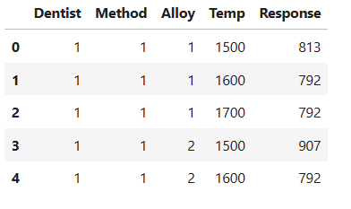
Figure 7: Dental implant data
There are no nulls in the dataset
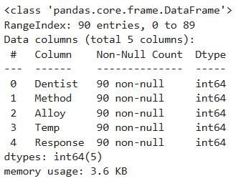
Figure 8: Data Description of Dental Implant data
Since there are 2 different Materials in the dataset, it is the best practice to split the dataset based on type of Alloy.
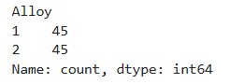
Figure 9: Alloy Types in Dental implant data

4.1 How does the hardness of implants vary depending on dentists?

Effect of Dentists Alone: For Alloy 1
The p-value (0.1166) is greater than 0.05, indicating that there is no significant difference in the hardness of implants based on dentists alone for Alloy 1.
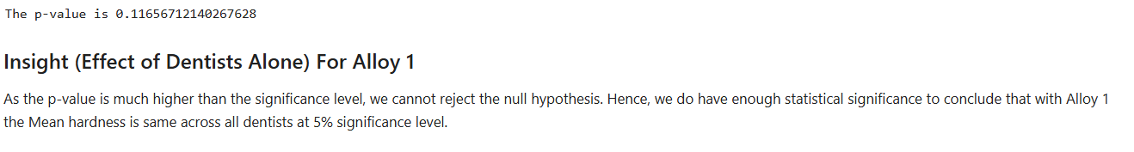
Figure 10: Evidence of p-value
Effect of Dentists Alone: For Alloy 2
The p-value (0.7180) is greater than 0.05, indicating that there is no significant difference in the hardness of implants based on dentists alone for Alloy 2.
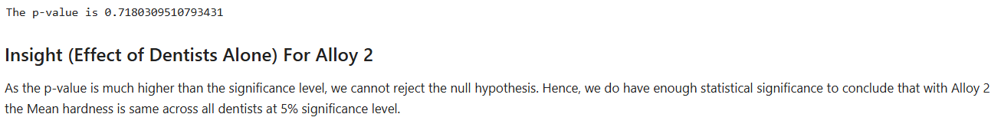
Figure 11: Evidence of p-value

4.2 How does the hardness of implants vary depending on methods?

Effect of Methods Alone: For Alloy 1
- The p-value (0.0042) is less than 0.05, indicating a significant difference in the hardness of implants based on the method used for Alloy 1.
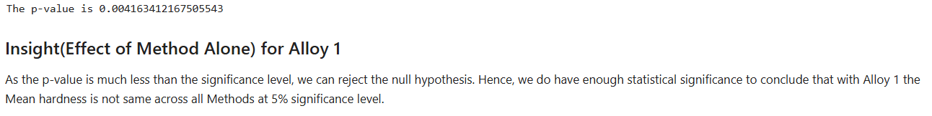
Figure 12: Evidence of p-value

Effect of Methods Alone: For Alloy 2
- The p-value (0.000005) is much less than 0.05, indicating a highly significant difference in the hardness of implants based on the method used for Alloy 2.
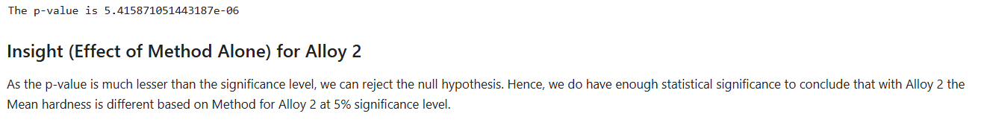
Figure 13: Evidence of p-value

4.3 What is the interaction effect between the dentist and method on the hardness of dental implants for each type of alloy?

Interaction Between Dentists and Methods: for Alloy 1
The p-value for the interaction term (0.0067) is less than 0.05, indicating a significant interaction effect between dentists and methods on the hardness of implants for Alloy 1.
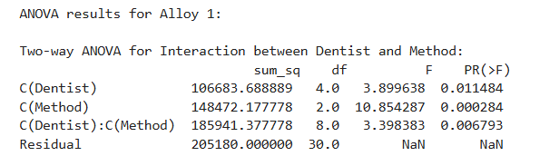
Figure 14: Evidence of p-value
Interaction Between Dentists and Methods: For Alloy 2
The p-value for the interaction term (0.0933) is greater than 0.05, indicating that there is no significant interaction effect between dentists and methods on the hardness of implants for Alloy 2.
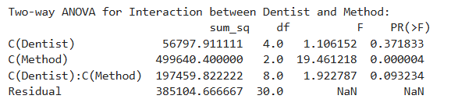
Figure 15: Evidence of p-value

4.4 How does the hardness of implants vary depending on dentists and methods together?

Two-way ANOVA for Dentists and Methods (Alloy 1)
Effect of Dentists Alone: The p-value (0.0519) is slightly above the significance level of 0.05. This indicates that there is a borderline significant effect of different dentists on the hardness of implants for Alloy 1. It is not strong enough to decisively reject the null hypothesis but suggests that the dentist might still have a mild effect.
Effect of Methods Alone: The p-value (0.0022) is much less than 0.05, which means there is a significant effect of the methods used on the hardness of implants for Alloy 1. This implies that the method of implantation has a notable impact on the hardness.
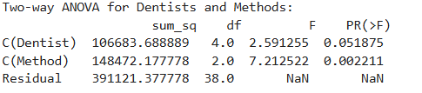
Figure 16: Evidence of p-value

Two-way ANOVA for Dentists and Methods (Alloy 2)
Effect of Dentists Alone: The p-value (0.4599) is significantly higher than 0.05, indicating that there is no significant effect of different dentists on the hardness of implants for Alloy 2. This means that the dentist performing the implant does not have a notable impact on hardness.
Effect of Methods Alone: The p-value (0.000038) is much less than 0.05, which shows a highly significant effect of the methods used on the hardness of implants for Alloy 2. This strongly suggests that the method of implantation plays a crucial role in determining the hardness.
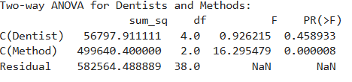
Figure 17: Evidence of p-value

